OSSP (Operating Systems And Systems Programming) - 25CS2104E

Practical
- Develop a C program using fork() that creates a parent and child process. Display the Process ID (PID), Parent Process ID (PPID), and process states at different stages of execution.
Design an experiment to observe process state transitions (Ready, Running, Waiting, Terminated) using Linux monitoring tools such as ps, top, and /proc. Document the observations

STEP 1: OPEN TERMINAL
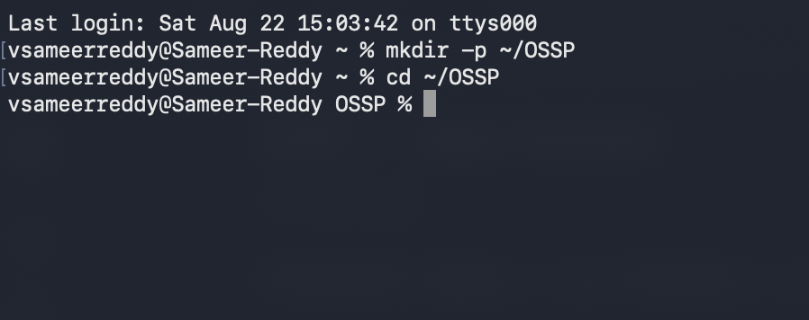
STEP 2: CREATE/OPEN OSSP FOLDER\

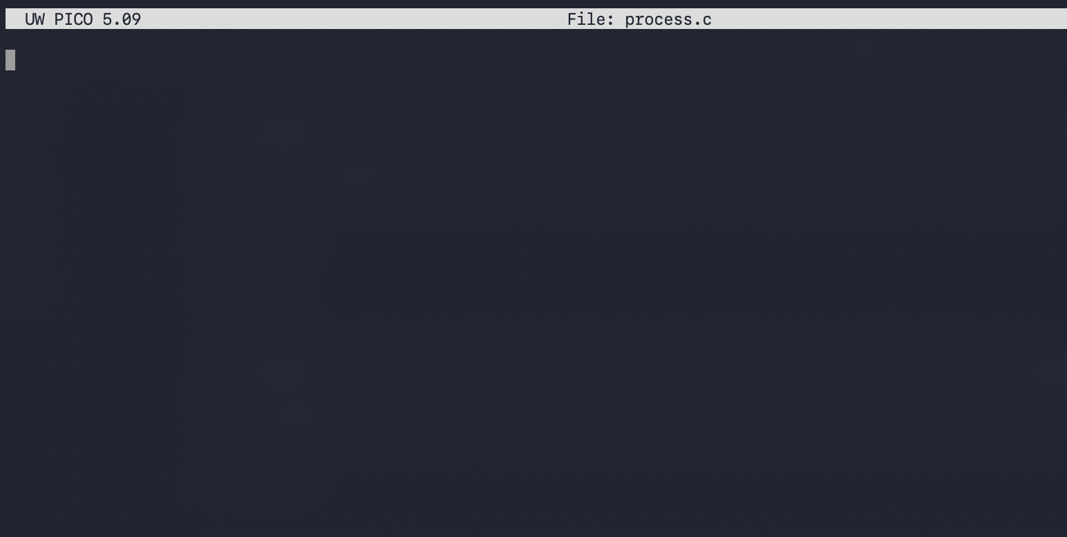
STEP 3 - CREATE THE C FILE
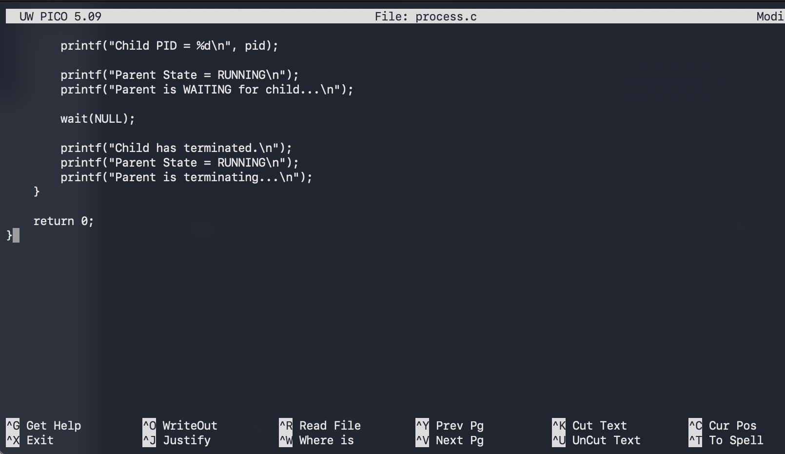
STEP 4 - TYPE THE CODE

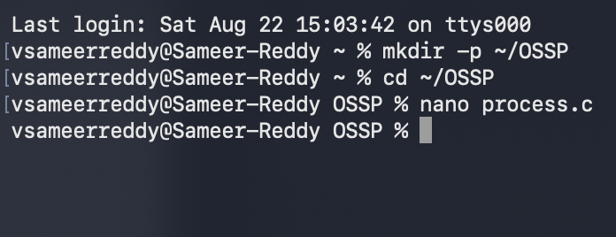
STEP 5 - SAVE THE FILE

STEP 6 - COMPILE
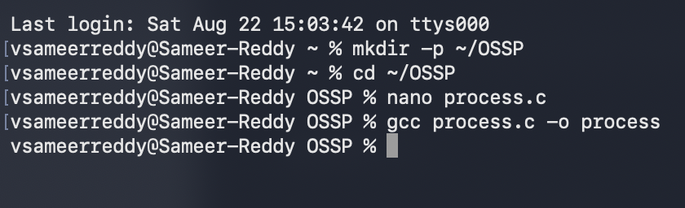

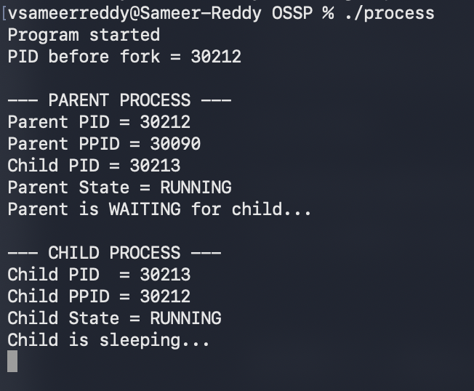
STEP 7 - RUN THE PROGRAM

STEP 8 - OPEN A SECOND TERMINAL WINDOW

Don’t close the first Terminal.
OPEN another Terminal:
Command + Space -> Terminal -> Enter

Terminal 1
C program is running
Terminal 2
Will Oberve the processes
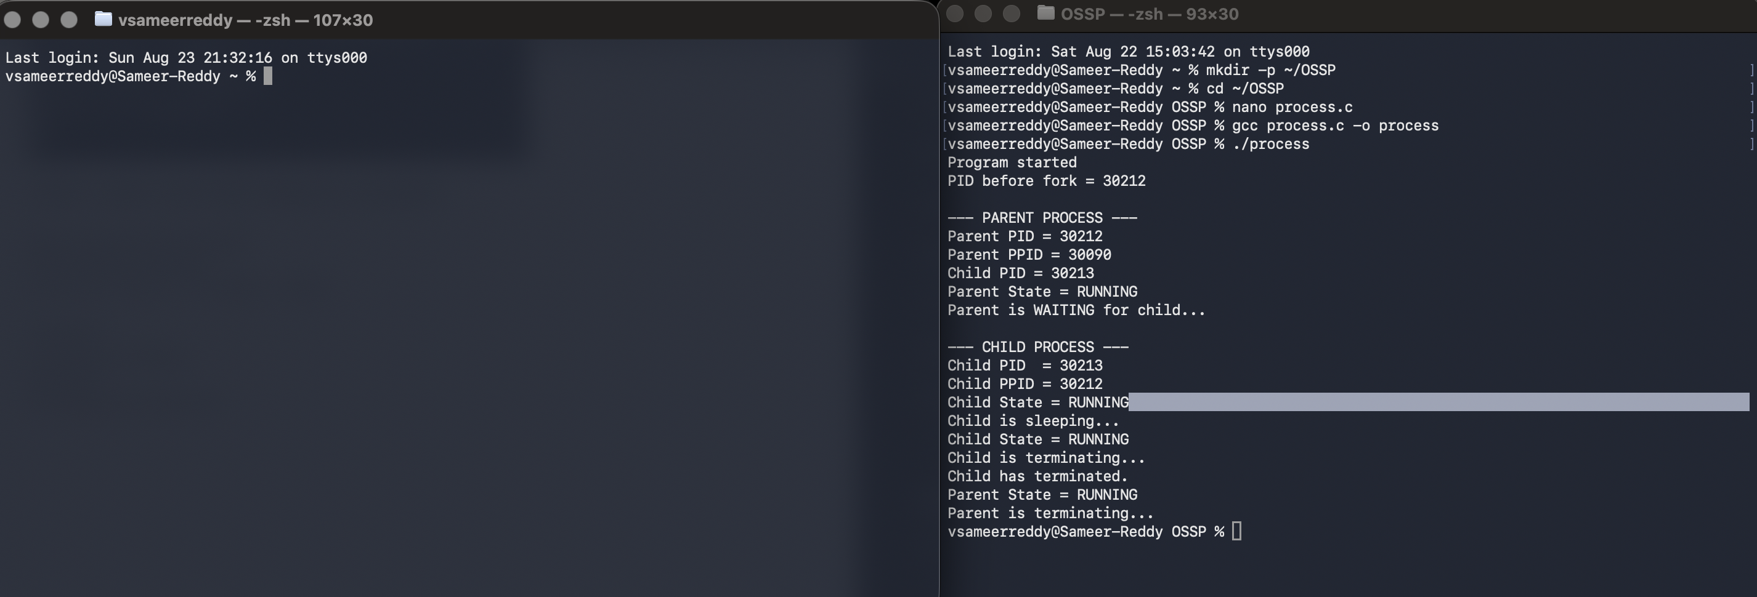

STEP 9 - FIND YOUR PROCESS
Type
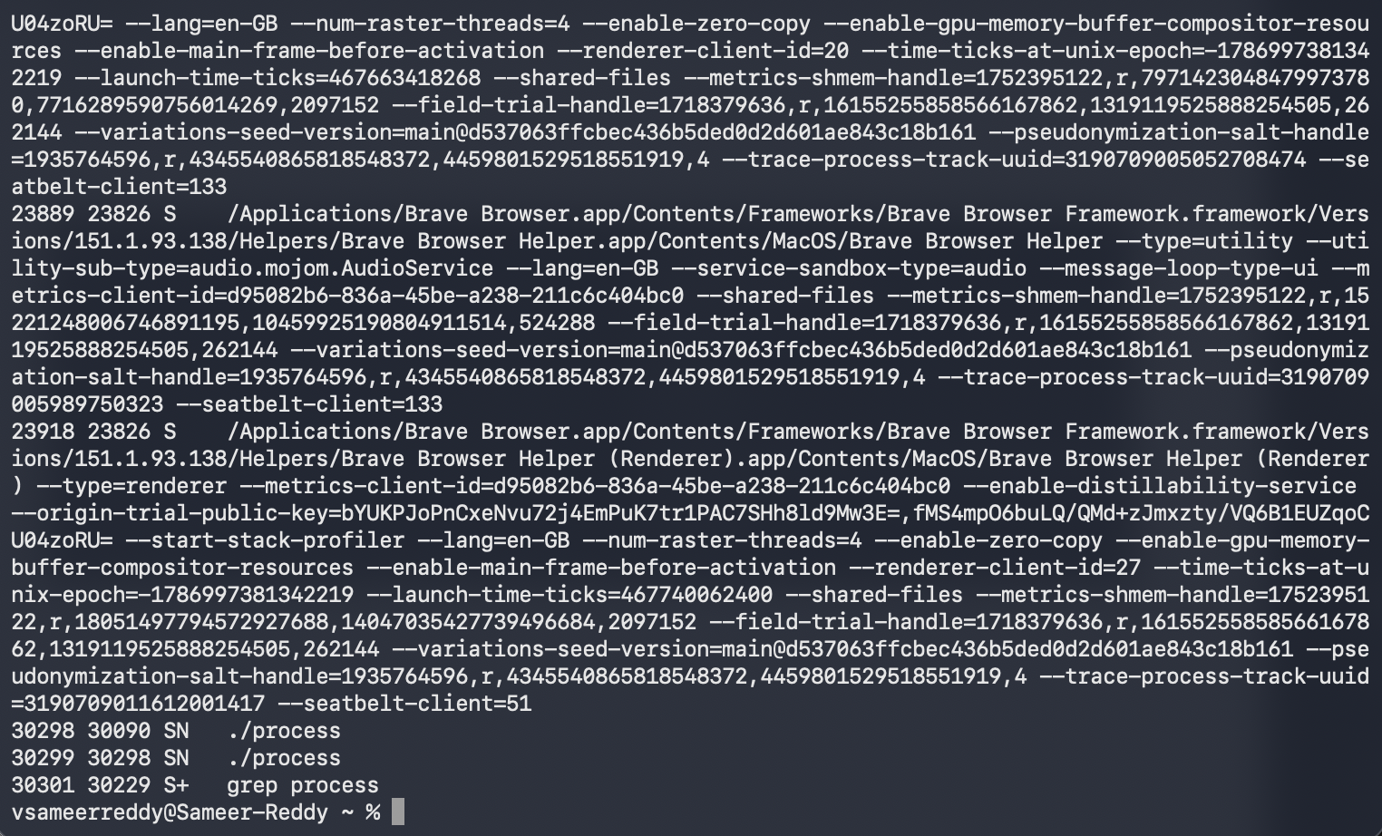
ps -ax -o pid,ppid,state,command | grep process

STEP 10: UNDERSTAND S
This means:
Sleeping/Waiting
Because our child program contains:
sleep(30);
So the child is temporarily waiting
The parent is also waiting because it contains
wait(NULL);

STEP 11 -USE top
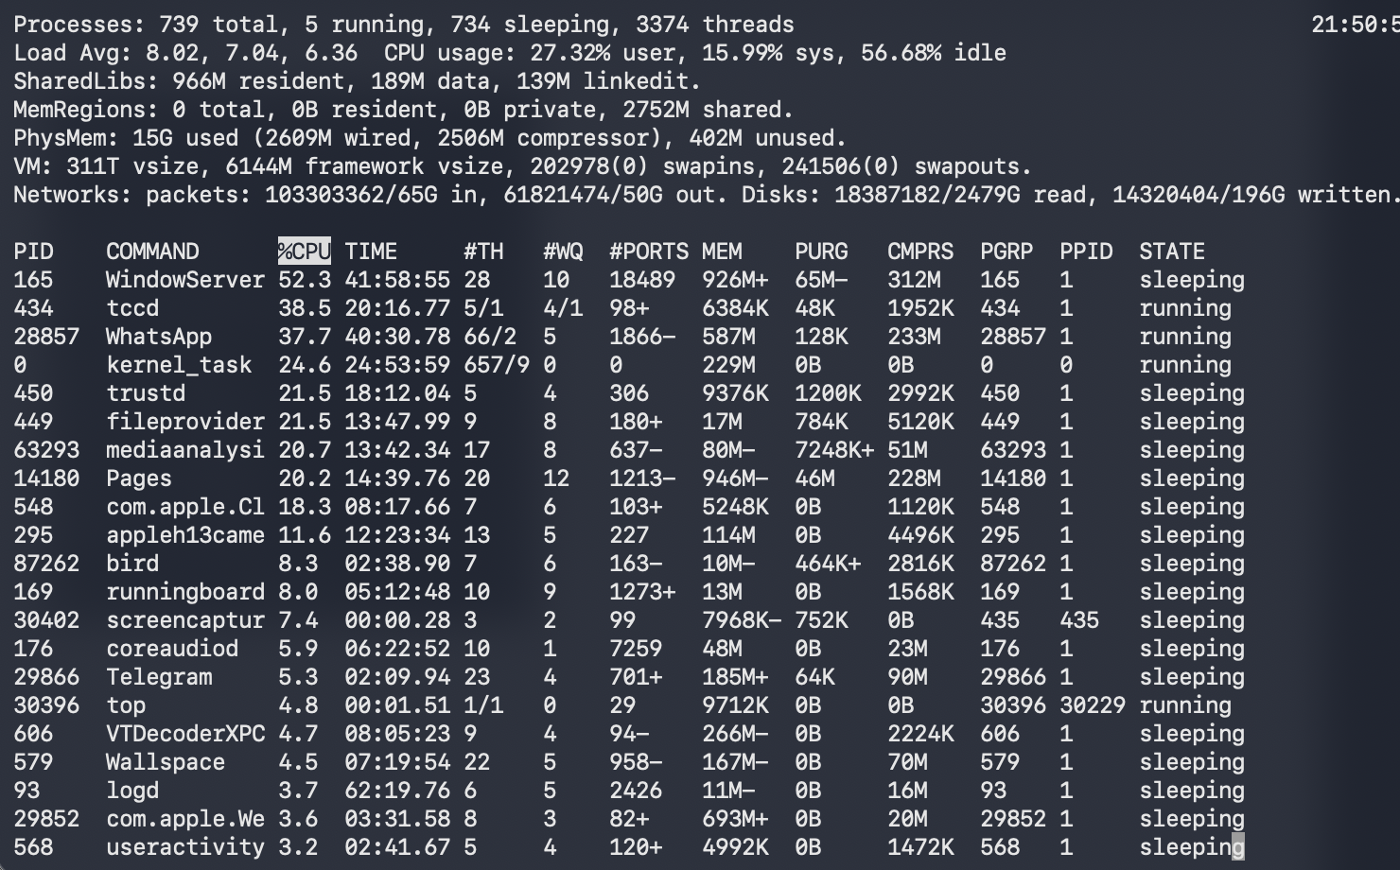
IN TERMINAL 2

STEP 12 - WHAT HAPPENS AFTER 30 SECONDS?
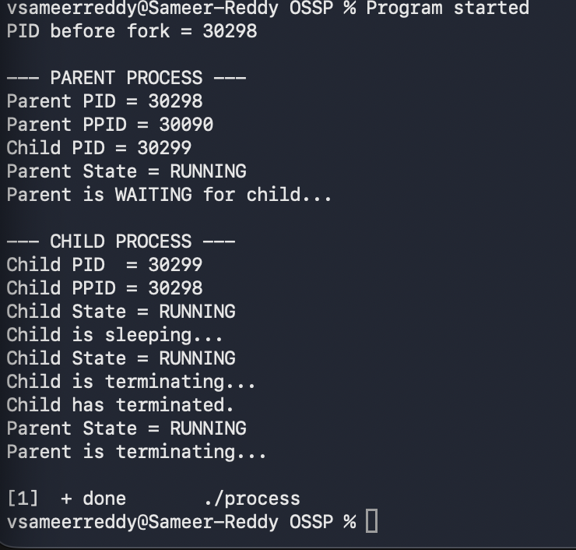
GO BACK TO TERMINAL 1

THE PROGRAM FINISHES
RESULT:
The parent and child processes were successfully created using fork().Their PID and PPID were displayed and Running,Waiting/Sleeping, and Terminated states were Observed using ps and top on macOS

